IRB Electronic Submission Process
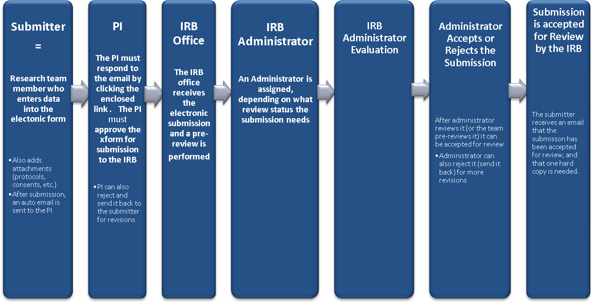Stages

