Process for Making an Electronic Submission for a NEW study

- Log on to the system using the user ID and password supplied by the IRB office. The client name is “evms”.
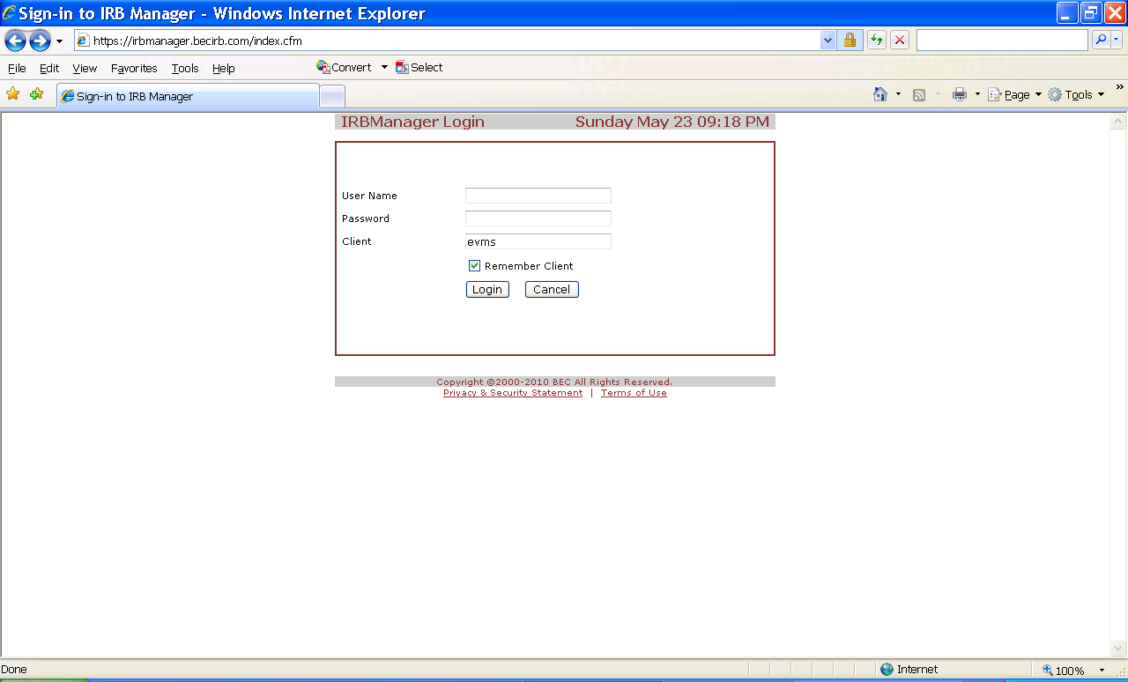

- The following type of screen should appear. On the left hand side of the screen, locate the area called “My documents & Forms”. Click on “xforms”.
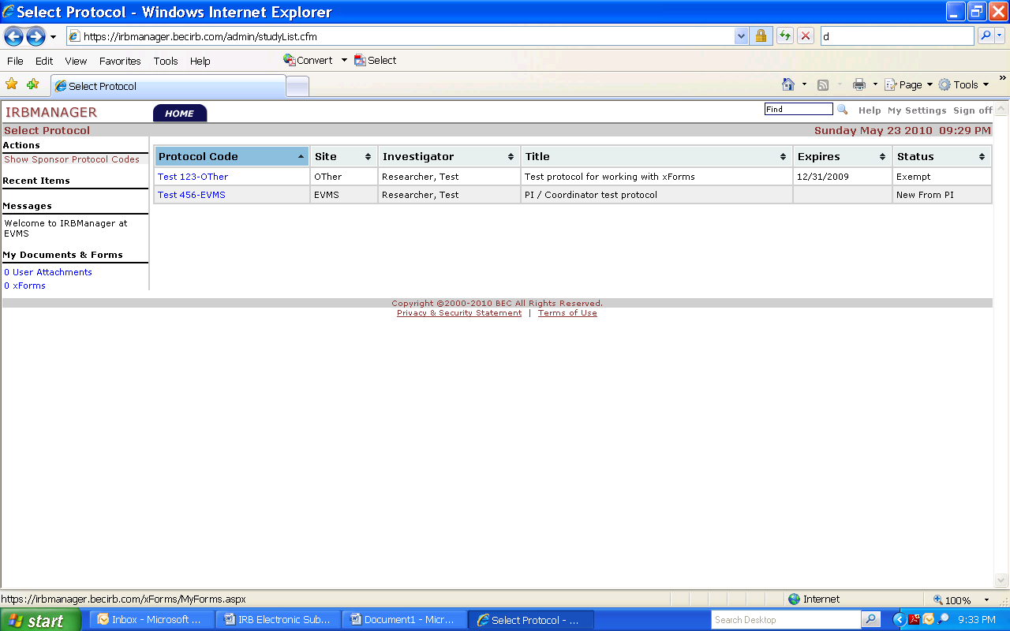

- The following screen will appear, which should show all active and processed electronic submissions (“xforms”) that have been submitted by the user that is currently logged in. It may show zero forms if you have not submitted anything before. On the left hand side of the page, click “Start Form”.
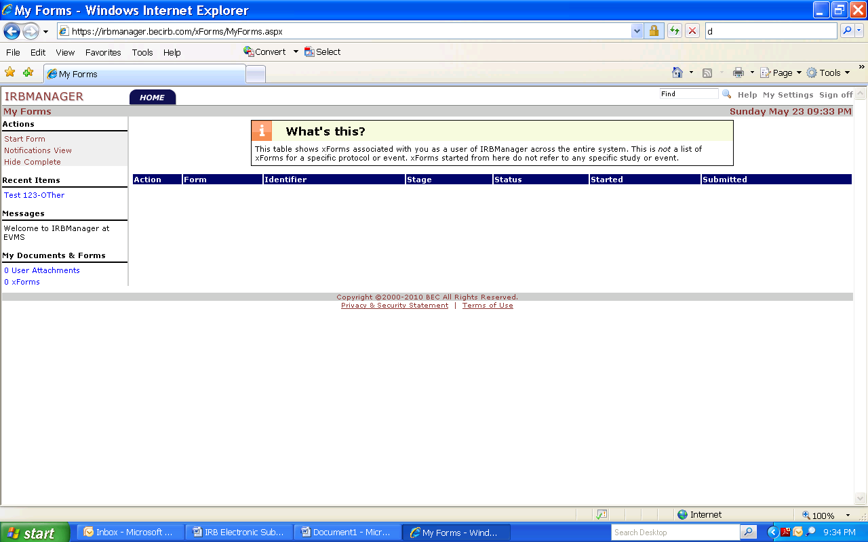

- The following screen should appear. Select they type of new study you are submitting for review, and complete the form.
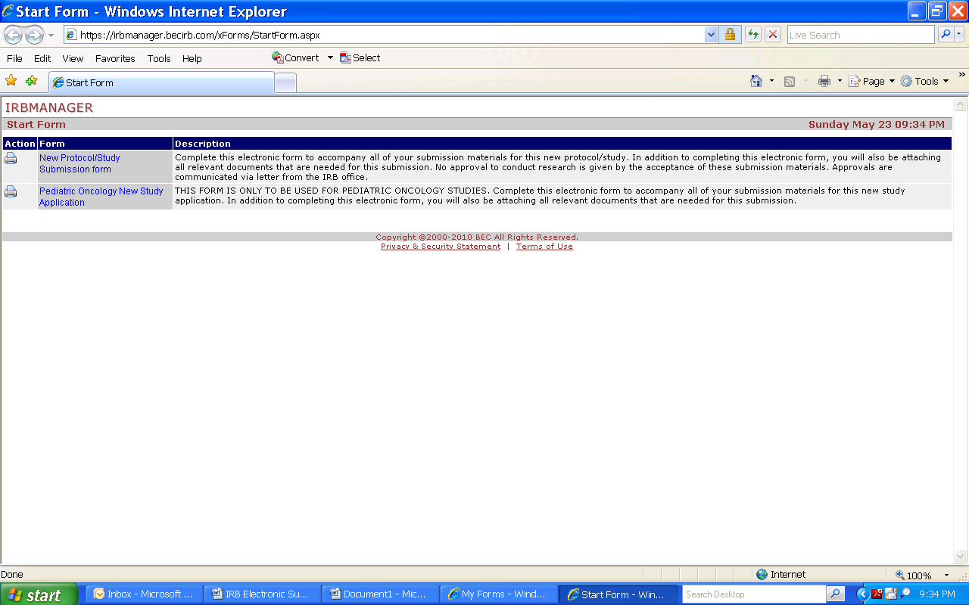

- After you have successfully completed the xform, the following type of email will be generated and sent to the PI. The PI must click on the link in this email and electronically “sign” the submission for it to move forward to the IRB office!
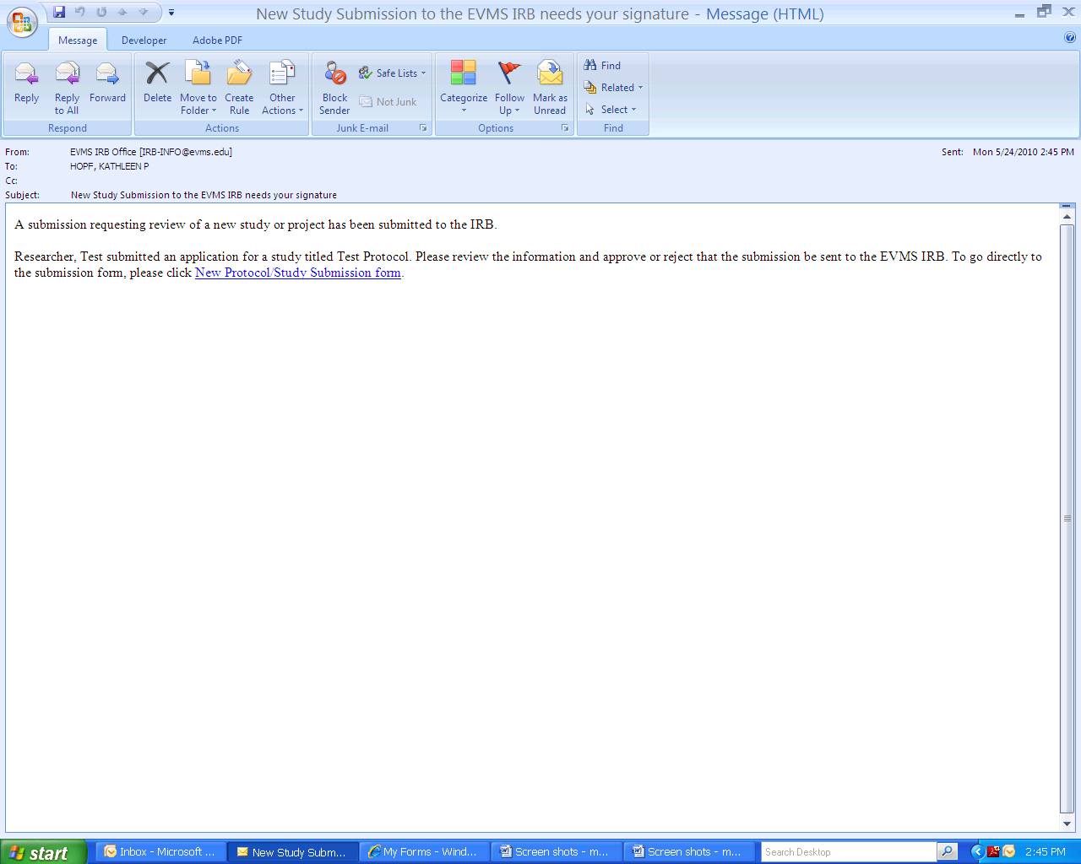

- After the PI signs off on the submission, it will move forward to the IRB office for processing. You (as the submitter) will be notified via email as to whether the submission was accepted for review, or whether it was rejected back to you for further changes/additions. If the submission is rejected back to you, follow the same process to resubmit your application.

