Downloading IRB Approval Documents

First: Log in to IRB Manager using your username and password.
- Click on the protocol which matches the notification email that was sent to you by the IRB staff.
- Scroll down to the “EVENT” (i.e., Amendment, Continuing Review, IRB Request for Changes to New Study, ect.)
*Please take note of the number (#) in parentheses, to the right of the EVENT.

Second: Click on the number in RED to the right of the Event
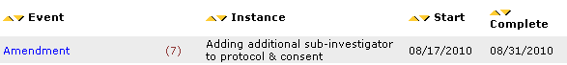

Note: This will bring you to the Associated Documents Web Page (or Attachments Page).

Third: Double click on the document containing the words “Approval Docs” to open it. This document may contain multiple items (IRB forms, Consent Forms, Protocol, etc.) so be sure to check how many pages there are before printing. (And, make sure you want all of them to print!!)
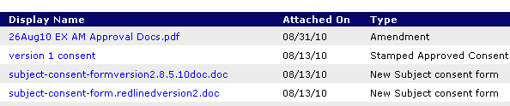

Please contact the IRB Office at (757) 446-8423 if you have questions or need assistance.

