For Principal Investigators – How to Approve a Submission if you have lost or deleted your email notification
An email is auto-generated to a PI whenever a submission has been entered into the electronic IRB system. Before the submission can be received by the IRB office, it must be approved by the PI. If a PI has lost or deleted their email notification, the following is an alternate way that PIs can access those submissions that need to be electronically “signed” and approved.

- For the PI: Log on to IRBManager at https://irbmanager.becirb.com/. Enter your user ID and password (the client is “evms”).
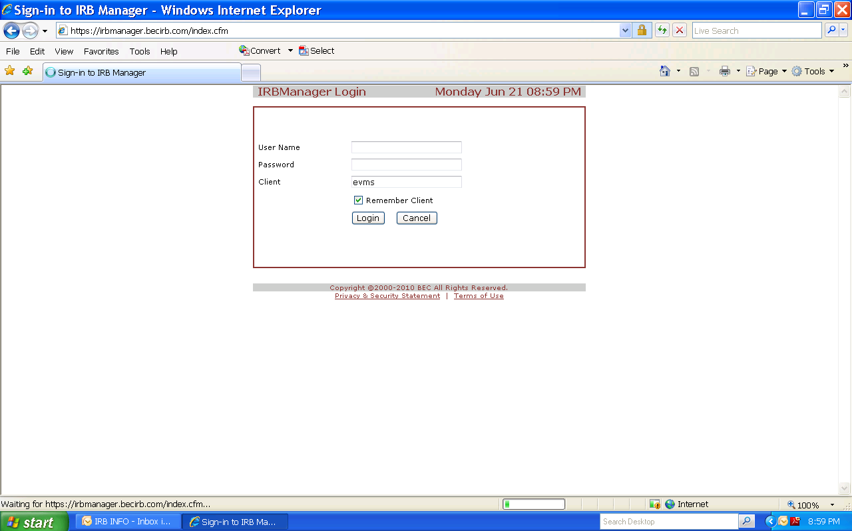

- On the Home screen (which shows all of your studies, past and present), select the hyperlink called “xforms”. The number in front indicates how many electronic submissions are currently associated with your user ID.
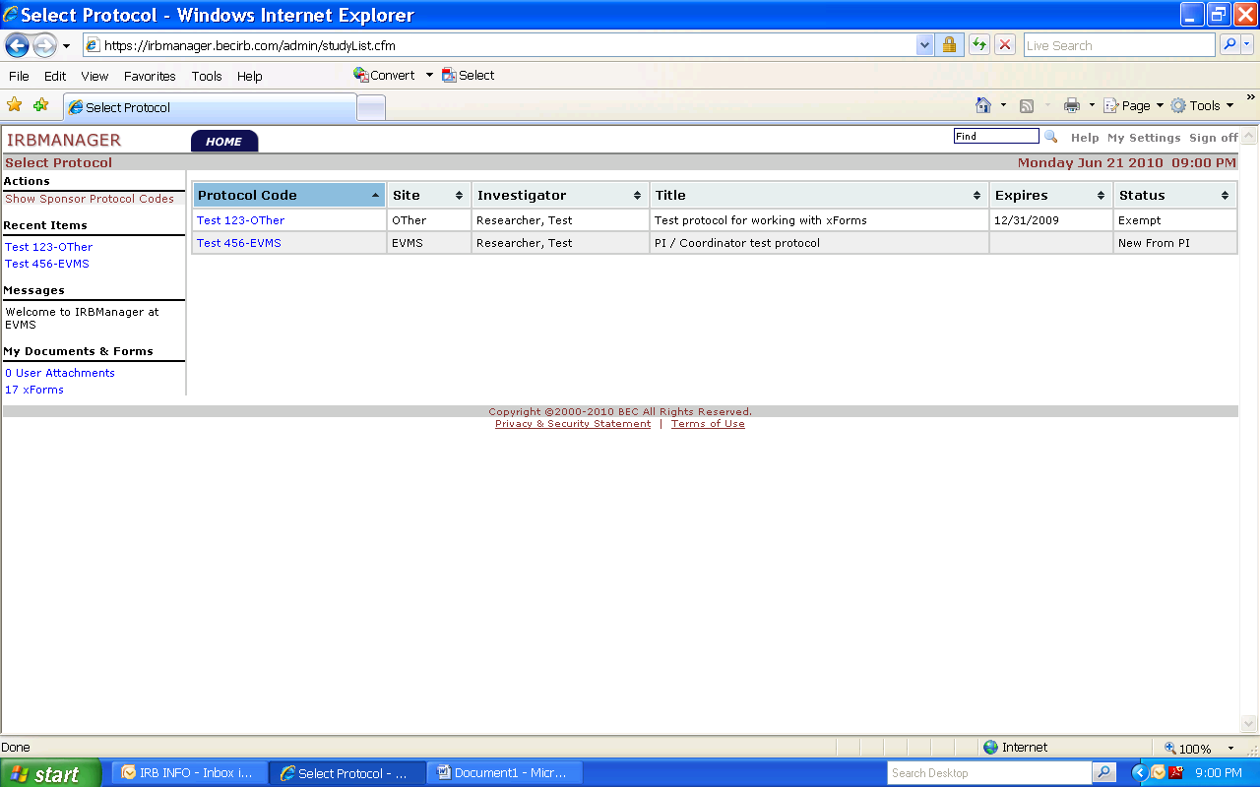

- On the next screen, select “Notifications View”.
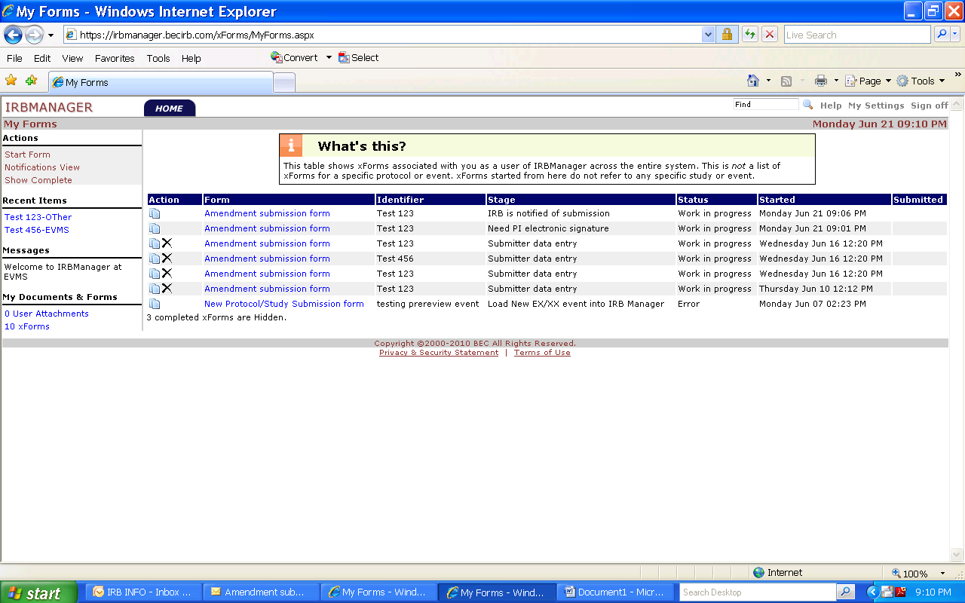

- The screen that appears shows all pending xforms/electronic submissions. Click on those links that have the “stage” name “Need PI Electronic Signature”. These are the submissions that are awaiting PI electronic signature
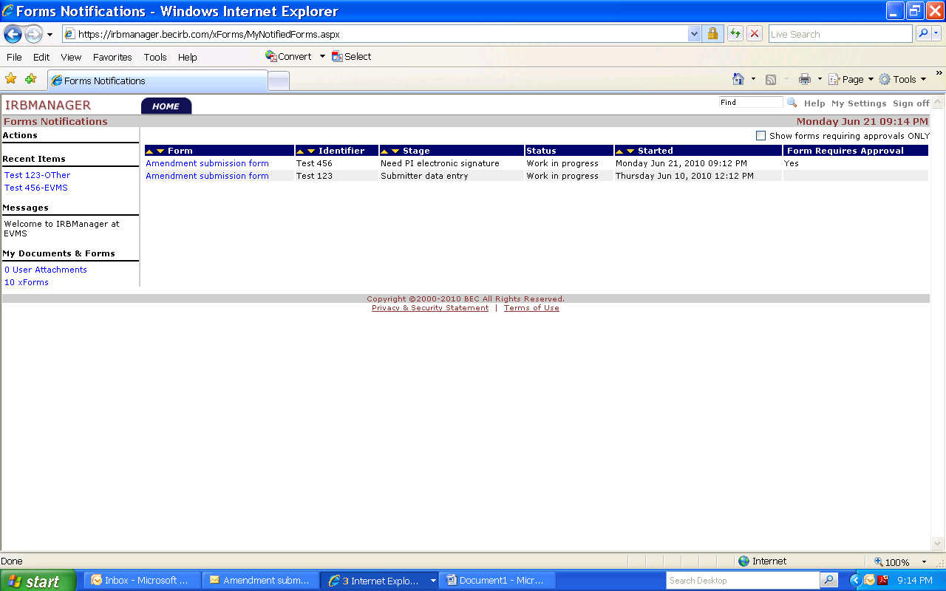
Click the hyperlink to open the form that needs PI electronic signature

- The form/submission will open. Review the form for accuracy. Be sure to click “Next” to advance to the next screen(s).
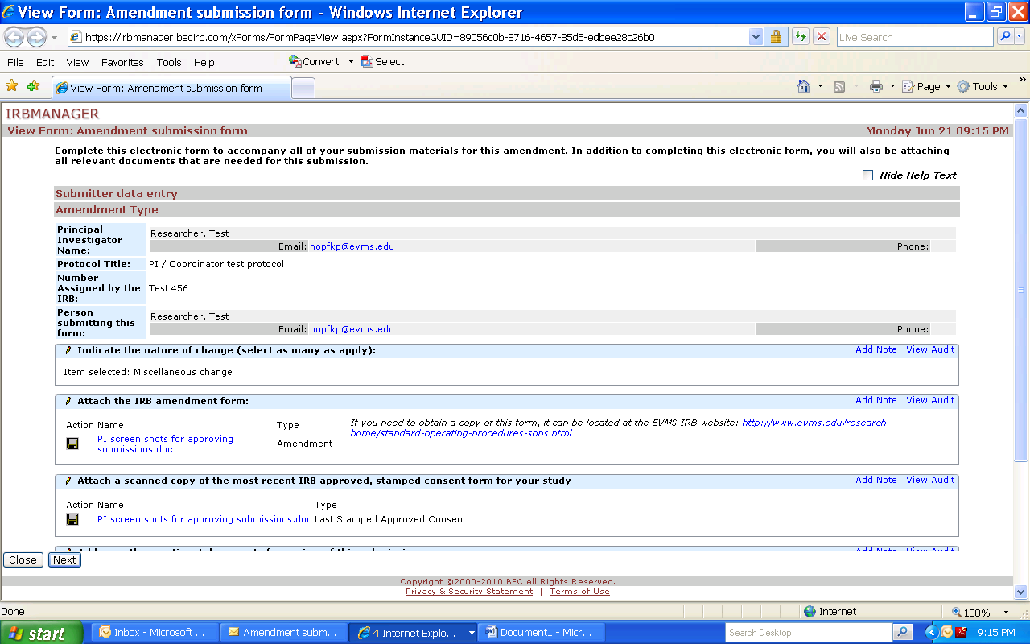

- At the next screen, click “Next”.
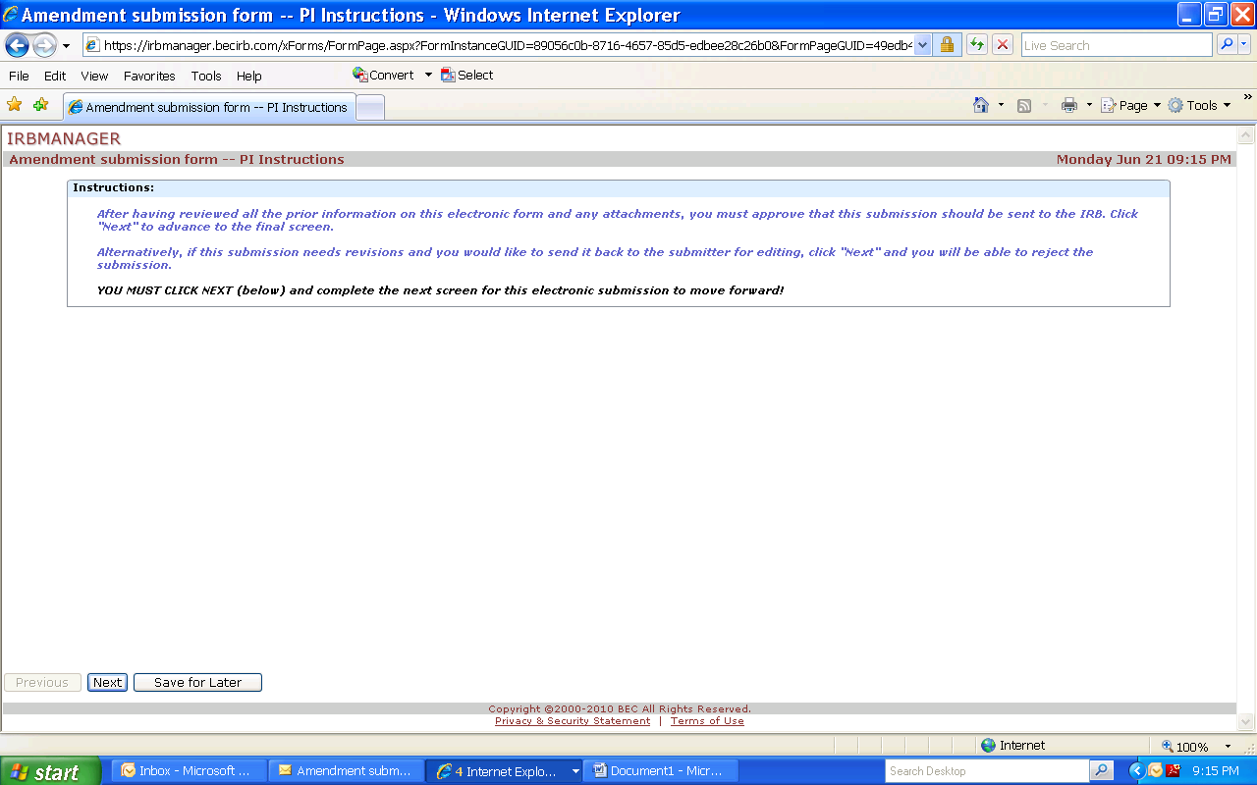

- At the final screen - You must either “approve” that the submission be sent to the IRB, or “reject” it back to your submitter to make any changes that you indicate. If you reject it, your submitter will receive an email notification of the rejection, make the changes, and resubmit it for your signature.
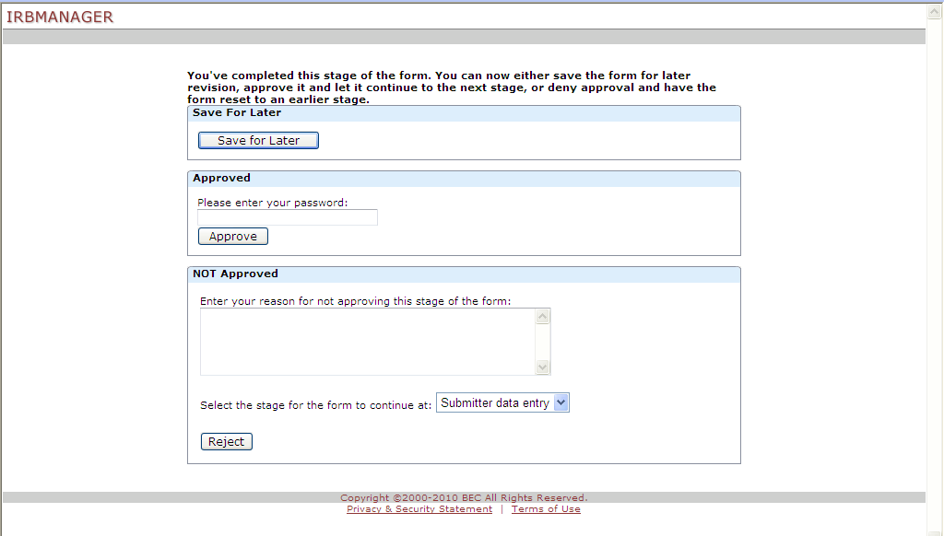
OR
To approve it, you must put in your password and click “Approve”
To reject it, you must put in your reasons for sending the submission back to the submitter, and click “Reject”.
Your submission will not reach the IRB until the submission is approved by you as the PI.

If you have any questions or encounter any problems, please call our office at (757) 446-8423.

