Instructions for Principal Investigators – How to Approve your electronic submissions
When you receive an email notifying you that you have a submission awaiting your approval, click on the link in the email. The link will direct you to the log in screen (below).
Follow this process:

- Log in using your user name and password. The client is “evms”
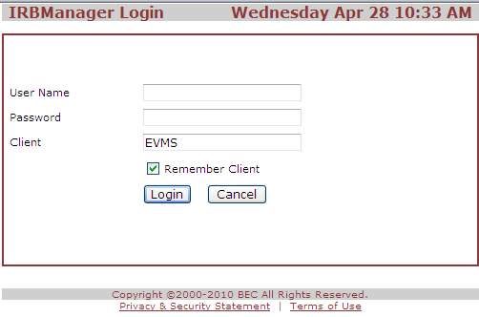
- Review the electronic form (“xform”) and any attachments, and click Next.
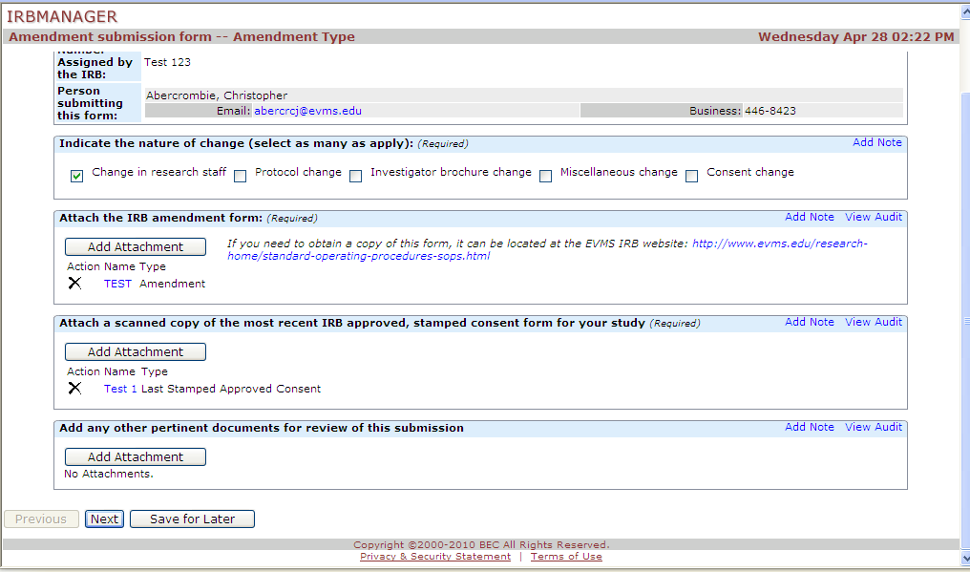
- Click Next again.
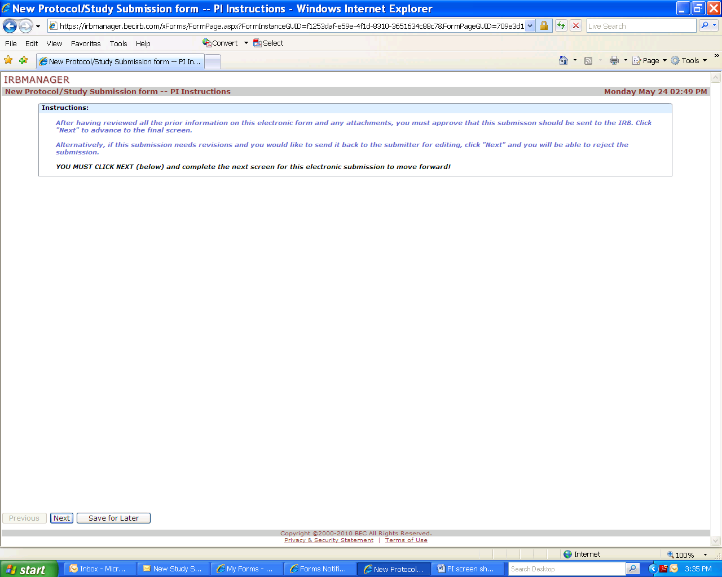
- Final Step: You must either “approve” that the submission be sent to the IRB, or “reject” it back to your submitter with any changes that you indicate.
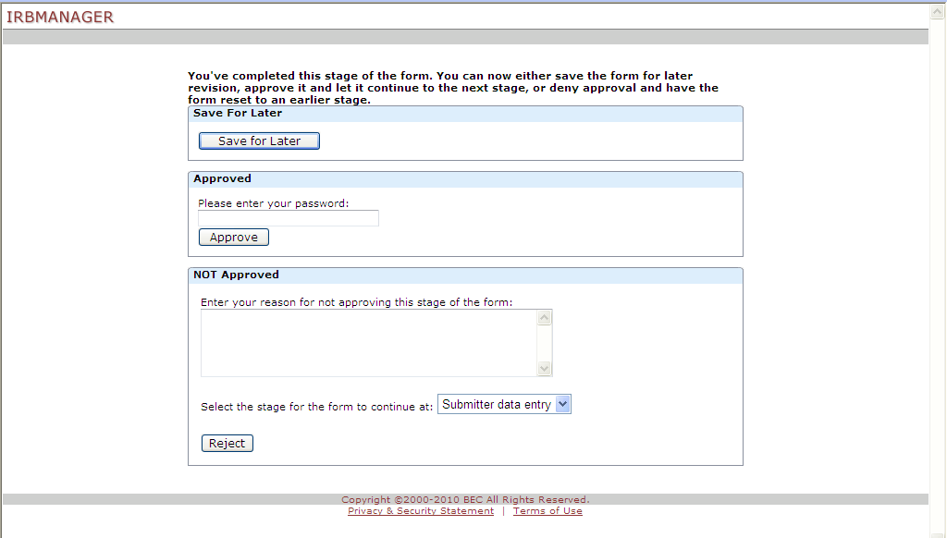
OR
To approve it, you must put in your password and click “Approve”
To reject it, you must put in your reasons for sending the submission back to the submitter, and click “Reject”.
Your submission will not reach the IRB without completing this final screen.

