Process for Making an Electronic Submission for an Existing Study
(e.g Amendments, Continuing Reviews, SAEs, etc.)

- Log on to the system using the user ID and password supplied by the IRB office. The client name is “evms”.
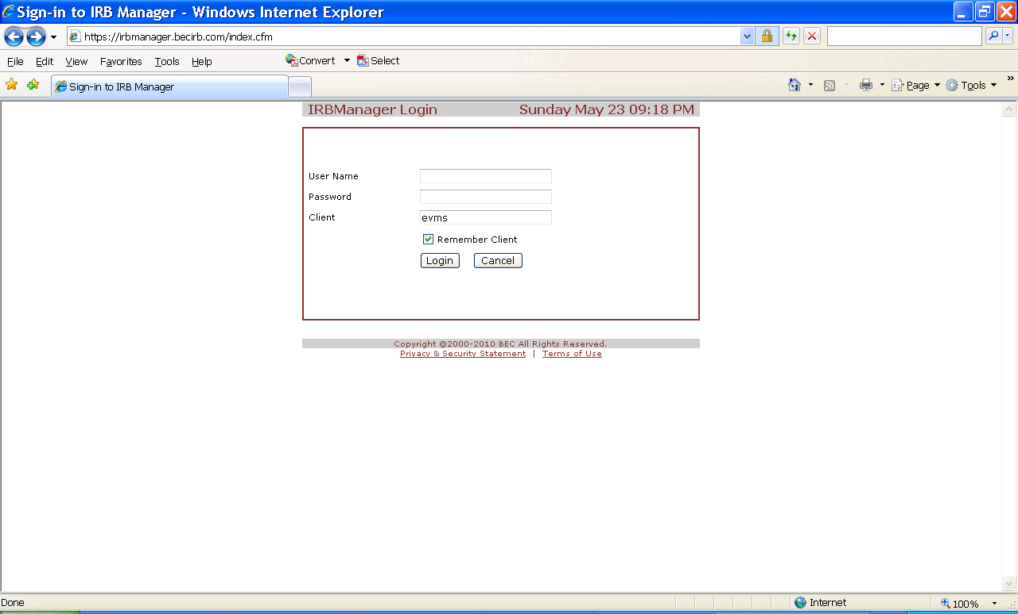

- After you login, you should see a table listing all current studies that are active (or have been active) under the EVMS IRB.

- Click on the study that you need to access and complete a submission for.

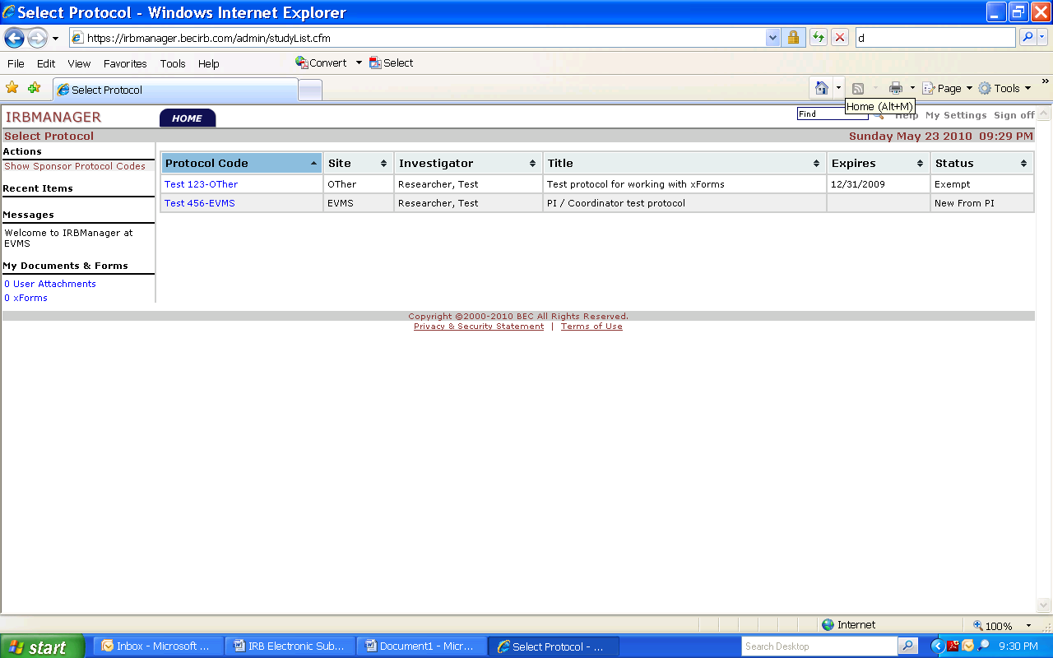
Click the link to the study that you need to select

- The protocol screen should appear (which lists the details and history of events for the study). On the left hand side of the page, click “Start xform”.
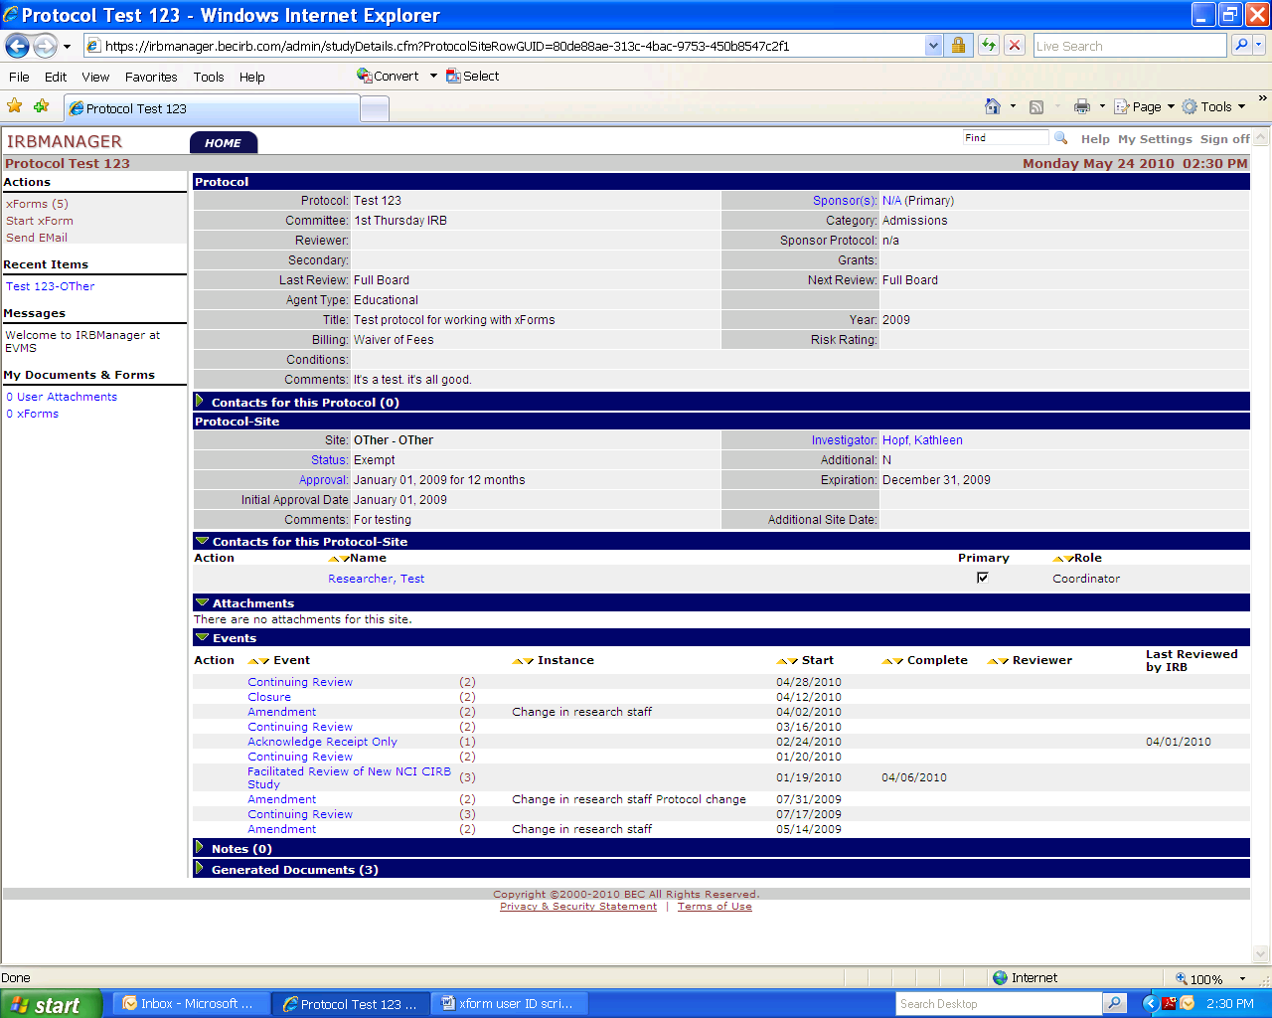

- A selection list should pop up. Select which type of submission you need to make. Click on the appropriate submission type, and complete the form.
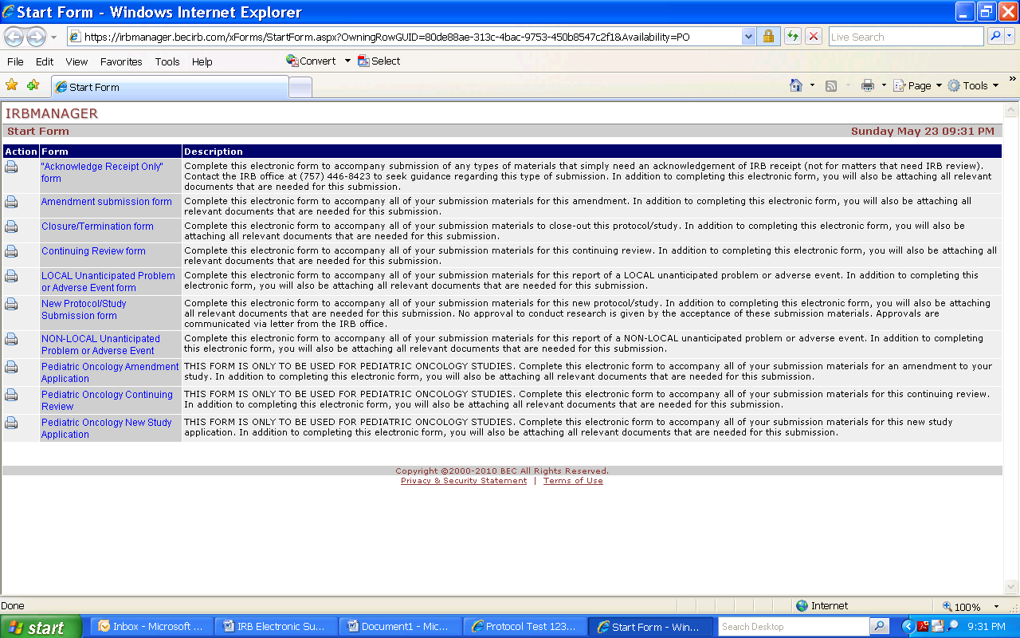
Select what type of submission you need to make, then complete the form (called an “xform”). Add all attachments as prompted by the xform.

- After you have successfully completed the xform, the following type of email will be generated and sent to the PI. The PI must click on the link in this email and electronically “sign” the submission for it to move forward to the IRB office!
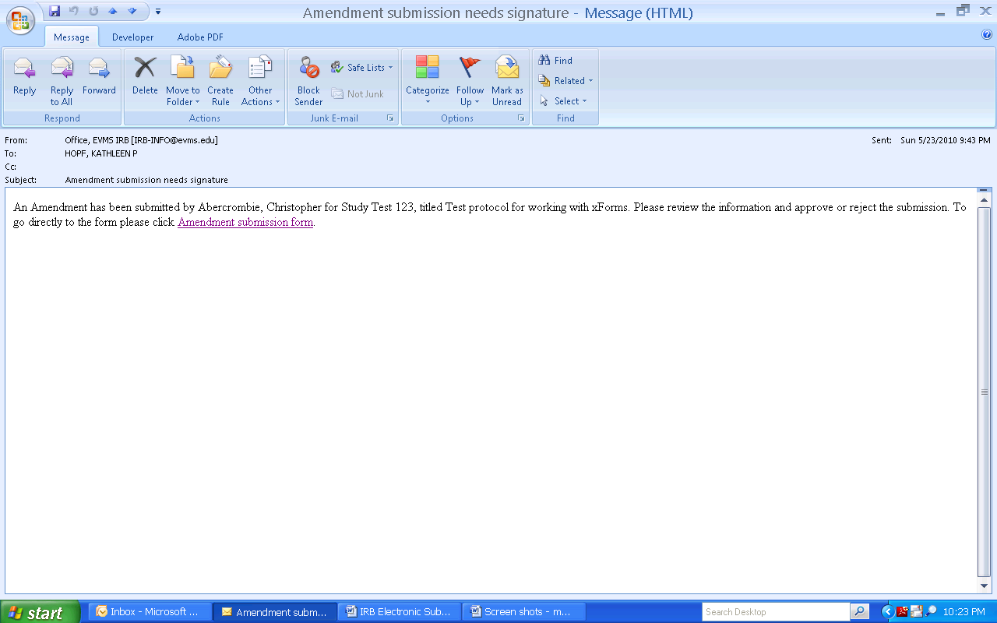

- After the PI signs off on the submission, it will move forward to the IRB office for processing. You (as the submitter) will be notified via email as to whether the submission was accepted for review, or whether it was rejected back to you for further changes/additions. If the submission is rejected back to you, follow the same process to resubmit your application.

